**My internship at Cadence Design Systems**



Internships play a crucial role in your in providing one with real-life experience and exposure. It is the first time when you get a taste of how the corporate world works. We can acquire behemoth amounts of learning through the course of our learning but the actual test of it comes only when we are able to apply that knowledge in the real world and an internship provides you with that experience. More than just showcasing your skills, it is also about learning from peers around you. I was fortunate enough to bang an internship at Cadence Design Systems during my summer break just after my 6th semester and in this blog, I would be sharing my experience at Cadence specifically about my role and the leanings I acquired there.

**About Cadence Design Systems**

Cadence is a leader in electronics design with over 30 years of experience in computer software. The company applies the underlying intelligent system design strategy to provide software, hardware, and IP that enable the design concept.

Cadence’s customers are the most innovative companies in the world, the most dynamic markets for consumers, hyperscale computing, 5G communications, automotive, aerospace, industry, and healthcare, from chips to circuit boards to systems. We provide excellent electronic products for applications.

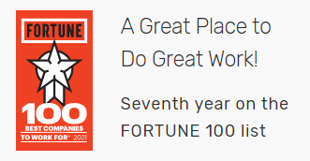

Fortune magazine has listed Cadence as one of the Top 100 Best Companies to Work For for the seventh consecutive year.

Apart from this, the other things that Cadence has a strong focus on are:

* Innovation: Think Big
* Quality: Execute with Excellence
* Agility: Move Quickly
* Integrity: Be Accountable
* One Cadence — One Team

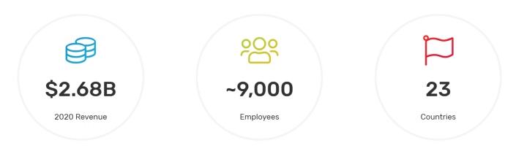

**My Role During the Internship**

I was hired as a Software Developer Intern at Cadence. I was part of Licensing, Installation, and Release Operations (LIRO) Team at Cadence Design Systems.

***Team Charter:*** *Enable Cadence products by providing technology and tools to deliver secure license key enabled products to end-users. Provide technology and tools to support Fulfillment and License Compliance.*

I worked on many projects during the course of my internship. I would be referring to them as Project A and Project B etc. due to the Non-Disclosure Agreement I was made to sign.

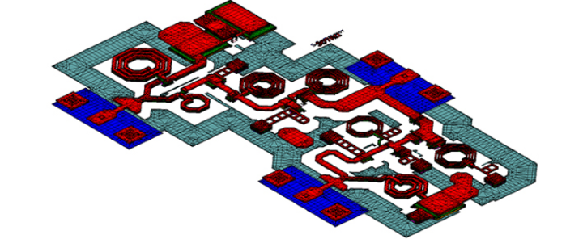

Cadence products are licenced and protected utilising proprietary and third-party technologies, as well as Flexera's FlexNet technology.

* .***Project A***

This homegrown solution allows Cadence customers to scale their license server to many orders of magnitude than the Flexera server. I had to make sure that the new features that were introduced were in line with the requirements and no unnecessary license check-in and check-outs were happening.

* ***Project B***

Enhance Cadence Licensing and License Compliance ecosystem to support IPv6. This was a migratory step that Cadence took wherein I had to ensure that all the previous features were working fine when exposed to the new tech stack.

* Apart from specific products I had to also perform daily regression and sanity tests which as the name suggests that the previous features were working correctly without any bugs.

**Technologies And Frameworks I used**

* Google Test
* C++ Programming Language
* MobaXterm
* Eclipse IDE
* JIRA



**My learnings**

* Truly understood the meaning of Testing and Automation. For a very long time, I felt that Testing was almost all about manually finding out errors. But after the internship, my perception of Testing changed drastically.
* Importance of Agile Methodology in a corporate world.
* Acquired the work habits and mindsets required to excel in the corporate world.
* Improved communication, interpersonal, and other important abilities. Daily standups aided me greatly in developing these abilities.
* And the most important — the corporate world is totally different from the university world.

**Conclusion**

I would like to thank the [CSE Department](https://www.linkedin.com/in/csebennett/) and Placement Department of my college for providing me with this wonderful opportunity wherein I was able to learn a lot and which I believe would definitely help me in my future.

**BLOG LINK:** https://sparsh-chadha27.medium.com/my-internship-at-cadence-design-systems-886b8456f769